Dear Families: 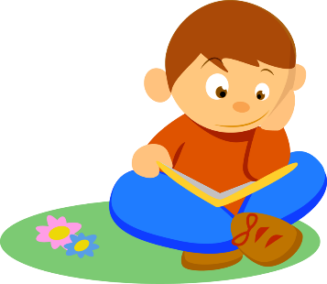

Here is some information about our current unit of study in reading.
Unit of Study: Unit 2: Becoming Experts Reading Nonfiction

This current unit of study will be broken up into three bends.

Bend 1: Thinking Hard and Growing Knowledge

- In this bend students will learn that nonfiction readers notice details and put them together to learn about a topic, and create questions about those details as they read.

- Students will learn that nonfiction readers ask themselves:
- What is this book teaching me?
- How does this book go? – Students will preview all parts of a book to determine what a book will teach them.

Bend 2: Learning the Lingo of a Topic

- Students will learn to use the vocabulary of a nonfiction topic as a part of their growing knowledge.

- Students will use text feature to notice and understand key words in a nonfiction text.

- Students will discover how to use the context of the whole page to understand undefined words.

- Students will understand the importance of rereading to grow more information about a topic.

- Students will learn how to use the lingo from the information they read to teach others.

Bend 3: Reading Across a Topic

- Students will learn to read multiple texts on a topic.

- Students will think and rethink how information is connected across books.

- Students will find, think, and talk about what is the same and what is different between the subtopics in their texts.

