Dear Families: 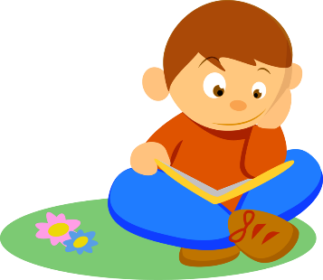

Our Current Unit of Study is: : Series Reading

Essential Question for this unit:
How can I use all that I know about fiction to read books in a series by noticing patterns, making predictions, and comparing and contrasting elements across series?

In this unit students will learn:

- How to notice patterns that stretch across a series in order to understand how the series is written and to use patterns to make predictions about the characters, setting, and problem.

- How to navigate trickier patterns and breaks in patterns to grow their understanding of –and ideas about- series books and characters.

- How to work with their reading club to look across series, comparing and contrasting elements to grow their ideas.

What you can do to help your child practice skills that will be taught in this unit:
- Read books from within a series either on their own, or with a parent.

- Some great series for second grade are:
  - Henry and Mudge
  - Mr. Putter and Tabby
  - Frog and Toad
  - Nate the Great
  - Cam Jansen
  - Horrible Harry
  - Polk Street School
  - Magic Tree House
  - Junie B. Jones
  - Bailey School Kids
  - A to Z Mysteries
  - Jigsaw Jones
  - Stink and Judy Moody
  - Amber Brown
  - Ramona (Beverly Cleary)

- Things to have your child notice while reading:
  - What patterns are you noticing in your books (repetition, character behavior, similar problems, story elements, settings, etc.)?
  - What predictions can you make based upon the patterns?
  - Can you revise or change your prediction based upon new evidence?

