Dear Families: 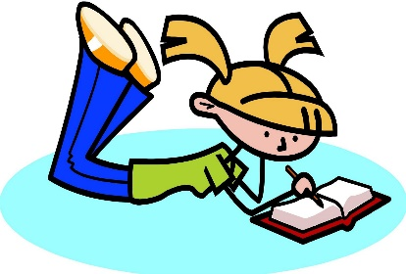

Our Next Writing Unit of Study is: Writing about Reading

This unit is made up of three bends.

Bend 1: Letter Writing: A Glorious Tradition

- Students will share their opinions about characters and develop new ideas about their characters by looking at elements such as pictures within the text.

- Students will learn to retell parts of the story in order to help their readers fully understand their opinion.

- Students will learn to keep their audience in mind by angling their writing towards their readers and writing as if they were talking to them.

Bend 2: Raising the Level of Our Letter Writing

- Students will learn that writers make their letter writing stronger by writing opinions about more than one part of the book.

- Students will learn that writers read closely and carefully, paying attention to details and they use these details to grow new ideas.

- Students will learn to look for multiple pieces of evidence to support each of their opinions.

Bend 3: Writing Nominations and Awarding Favorite Books

- Students will learn that writers of nominations choose topics that they have strong opinions about, making cases for them by including evidence.

- Students will learn that writers often make comparisons to support their opinions. They compare characters, stories, or kinds of books to explain why they think one is better or not.

- Students will learn to give specific evidence from the text to support their thinking and that sometimes portions of the text can be added directly to their writing through the use of quotation marks.

- Students will learn to use tools to help them evaluate their writing, figure out what they are doing well, and then make a plan for what they want to do better.

Join in on the conversation!
Don’t forget to ask your child what they are
learning about in writing.

Some things to talk about…
- What is an opinion letter?
- What things do you include in an opinion letter?
- How did you find evidence to support your opinion about a character or a book?
- What does it mean to talk to your audience when you are writing an opinion letter?

